Derivation for soft actuator play my:
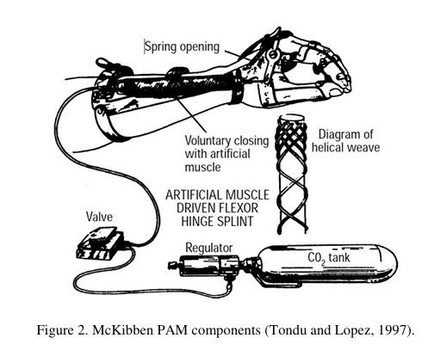
- In a first approach toward the model of a McKibben type PAM, losses are not considered and thus, the gas enters the PAM and expands, generating a traction force and a work. To generate the volume increase, the gas performs a work input (Win) that can be described.
dWin = ∫(P − Pex )dli.dSi
= (P − Pex) ∫dli.dSi
dWin = P’dV
Where, Pex = External Force,
P = Absolute Pressure
P’ = Relative Pressure
- As the pressure performs work by volume expansion and it is assumed that the system has no loss, all the work is converted into traction and can be expressed by Wout,
dWout = -FdL
Where, F is the axial tension and dL is the displacement.

The Conservation of Energy gives:
dWin = dWout
P’dV = -FdL
F = - (P’ dV)/dL ........................ (1)
- With the strength defined in terms of the volume change, just missing define the volume variation permitted by the mesh. The variation stops when volume reaches its maximum. At this moment, the muscle reaches the largest contraction.
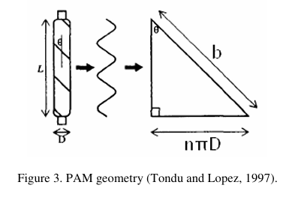
- Observing Fig.3, it is possible to make the length (L) and diameter (D) as a function of the angle (θ). This angle is one formed between the mesh and the axial length of the muscle. The length of fiber can be named b and n is the number of turns of the fiber around the muscle. Using b and n, it is possible to set the length and the diameter of the muscle.
$cosθ= \frac{L}{b}$
$L = b cos$…….……………………..…………………………… (2)
$sinθ =\frac{Dnπ}{b}$
$D= \frac{bsinθ}{nπ}$ …………….…….……………………………..……. (3)

Making the Volume equation as function of the diameter and D & length L.
$$V= \frac{1}{4}*πD^{2}L$$
By substituting D & L in eq 4
We get, $V= \frac{b^{3}}{4πn^{2}} *\left[\sin^{2}θ*cosθ\right]$……………………………….. (5)
Diff. eq (2) & eq (5) w. r. t. θ
$\frac{dL}{dθ}=-bsinθ$ ……………………………..….…..……………………. (6)
$\frac{dV}{dθ}= \frac{b^{3}}{4πn^{2}} *[3\cos^{2}θ -1]$ …….………………………………. (7)
Substitute the value of eq (6) & eq (7) in eq (1)
$F=-P^{'}* \frac{dV}{dL}=-P^{'}* \frac{\frac{dV}{dθ}}{\frac{dL}{dθ}}$
After substituting and rearranging, we get:
$F= \frac{P^{'}D^{2} (3\cos^{2}θ -1)}{4πn^{2}}$ ……………………............................... (8)
$D= \frac{bsinθ}{nπ}$
$\frac{D}{sinθ}= \frac{b}{nπ}$
By substituting the value of D & trigonometric relation in eq (8)
$F= \frac{π}{4} P^{'}D^{2}* \frac{(3\cos^{2}θ -1)}{\sin^{2}θ}$ ……………………………….….. (9)
Adopting contraction (ε) and applying Eq.9, it is possible to reach to required formulation (Daerden and Lefeber, 2000).
$D= \frac{bsinθ}{nπ}$ ………………………………… After applying pressure
$D_{0}= \frac{bsinθ_{0}}{nπ}$ ……….......................... Before applying pressure
$D = D_{0}$………………………………..……. Basic Interpretation
So, we can replace D & sinθ with D0 & sinθ0 in eq (9)
$cosθ= \frac{L}{b}$
$L = b cosθ$
$L_{0}= b cosθ_{0}$
$\frac{L}{L_{0}}= \frac{cosθ}{cosθ_{0}}$
By Rearranging,
$cosθ= \frac{L}{L_{0}} {cosθ}_{0}$ ……………………………..……………. (10)
Where, Contraction Factor (ε)
$$ε= \frac{L_{0}-L}{L_{0}}=1 - \frac{L}{L_{0}}$$
$1-ε= \frac{L}{L_{0}}$
Put this value in eq (10)
$cosθ=(1-ε){ * cosθ}_{0}$
Substitute cosθ, D = D0 & sinθ = sinθ0 in eq (9)
$F= \frac{π}{4} P^{'}D^{2}* \frac{(3{(1-ε)}^{2}{ * \cos^{2}θ}_{0}-1)}{\sin^{2}θ_{0}}$

